**Notes on Sunway TaihuLight**

http://www.nsccwx.cn/soft1.php?word=soft&i=46 [1]

* System peak performance: 125.436 GFlops
* measured continuous computing performance: 93.015 GFlops
* system memory: 1310720 GB
* Operating system: Raise Linux
* SSD storage: 230TB
* online storage: 10PB, bandwidth 288GB / s
* nearline storage: 10PB, bandwidth 32GB / s

(https://www.top500.org/site/50623) [2]

* Sunway TaihuLight was the top super computer at 2016/06, 2016/11, 2017/06 and 2017/11

[https://www.top500.org/system/178764 [3](https://www.top500.org/system/178764%20%5b3)]

* Cores: 10,649,600
* Processor: Sunway SW26010 260C 1.45GHz
* Power: 15,371.00 kW

http://www.nsccwx.cn/wxcyw/soft1.php?word=soft&i=46 [4]

* The Sunway TaihuLight system was supported by the National High Technology Research and Development Program ("863"Program) of China
* The supercomputer was developed by the National Research Center of Parallel Computer Engineering & Technology
* To support both high performance computing and big data applications, the Sunway TaihuLight uses a high-scalable heterogeneous architecture, a high-density integration of the system, a high-efficient DC power supply, and other key technologies such as the customized water cooling system. The supercomputer is also equipped with high-efficient scheduling and management tools, a rich set of parallel programming languages and development environments, so as to support the research and development operations on the system

http://www.nsccwx.cn/wxcyw/introduction.php?word=introduction&i=34 [5]

* The National Supercomputing Center, Wuxi（NSCC-Wuxi），coordinated and cooperated by Jiangsu Province, the city of Wuxi and Tsinghua University, hosts the new generation of Sunway TaihuLight Supercomputer.

[6] Fu, H., Liao, J., Yang, J. et al. Sci. China Inf. Sci. (2016) 59: 072001. <https://doi-org.ezproxy.library.uvic.ca/10.1007/s11432-016-5588-7>

(narrow this information down, #toomuch)

* “TaihuLight is provided by a homegrown many-core SW26010 CPU that includes both the management processing elements (MPEs) and computing processing elements (CPEs) in one chip.”
* “With 260 processing elements in one CPU, a single SW26010 provides a peak performance of over three TFlops.”
* “To alleviate the memory bandwidth bottleneck in most applications, each CPE comes with a scratch pad memory, which serves as a user-controlled cache.”
* “To support the parallelization of programs on the new many-core architecture, in addition to the basic C/C++ and Fortran compilers, the system provides a customized Sunway OpenACC tool that supports the OpenACC 2.0 syntax.”
* “As a successor of the Sunway BlueLight system, the Sunway TaihuLight system is also supported by 863 Program of China. Its peak performance is 125 PFlops, sustained Linpack performance is 93 PFlops, and performance per Watt is 6.05 GFlops/W.”
* “One major technology innovation of the Sunway TaihuLight supercomputer is the homegrown SW26010 many-core processor.
* The processor includes four core-groups (CGs).
* Each CG includes one management processing element (MPE), one computing processing element (CPE) cluster with eight by eight CPEs, and one memory controller (MC).
* These four CGs are connected via the network on chip (NoC). Each CG has its own memory space, which is connected to the MPE and the CPE cluster through the MC.
* The processor connects to other outside devices through a system interface (SI)”
* “The MPE is a complete 64-bit RISC core, which can run in both the user and system modes. The MPE completely supports the interrupt functions, memory management, superscalar processing, and out of-order execution. Therefore, the MPE is an ideal core for handling management and communication functions.”
* “In contrast, the CPE is also a 64-bit RISC core, but with limited functions. The CPE can only run in user mode and does not support interrupt functions. The design goal of this element is to achieve the maximum aggregated computing power, while minimizing the complexity of the micro-architecture. The CPE cluster is organized as an eight by eight mesh, with a mesh network to achieve low-latency register data communication among the eight by eight CPEs. The mesh also includes a mesh controller that handles interrupt and synchronization controls. Both the MPE and CPE support 256-bit vector instructions.”
* In terms of the memory hierarchy, each MPE has a 32 KB L1 instruction cache and a 32 KB L1 data cache, with a 256 KB L2 cache for both instruction and data. Each CPE has its own 16 KB L1 instruction cache, and a user-controlled scratch pad memory (SPM).
* The parallel operating system environment, which includes the parallel operating system, network management system, and availability and power management systems, provides computing, application, and management services, in addition to other system services to the users.
* The high-performance storage management system includes the parallel file system, lightweight file system, and storage management platform, which provide storage support for running system software and large-scale parallel I/O applications.
* In addition to the basic software, the TaihuLight system also has a parallel programming language and compilation environment to support parallelization at different levels
* For parallelization at the node level, MPI is generally applied. For the four CGs within the same processor, we can either use MPI or OpenMP. For parallelization within a CG, we use Sunway OpenACC, a customized parallel compilation tool that supports OpenACC 2.0 syntax and targets the CPE clusters. The customized Sunway OpenACC tool supports parallel task management, heterogeneous code extraction, and data transfer descriptions.

http://www.netlib.org/utk/people/JackDongarra/PAPERS/sunway-report-2016.pdf

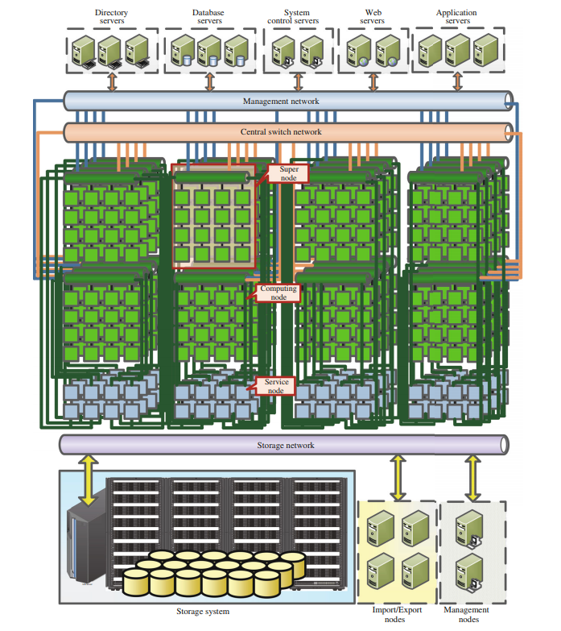

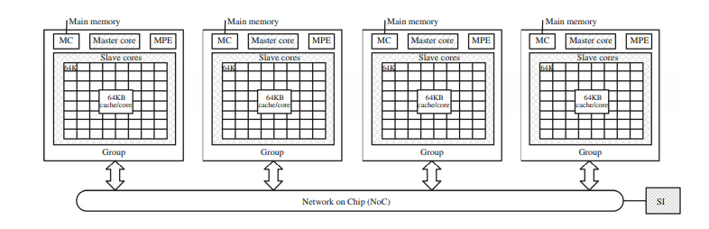

There are currently four key application domains for the Sunway TaihuLight system:

• Advanced manufacturing: CFD, CAE applications.

• Earth system modeling and weather forecasting.

• Life science.

• Big data analytics.

COST of the big boi US$273 million